Hack-A-Jeep Documentation

1. First Hack (Sharon, Saad, Dona, Hannah) ------------------------------------ 2
2. Second Hack (Shi En, Hannah) -------------------------------------------------- 4
3. Connection Diagram -------------------------------------------------------------- 6
4. Components Used ----------------------------------------------------------------- 7
5. Controller by Phone App --------------------------------------------------------- 8
6. Current Configuration ------------------------------------------------------------ 9
7. Further work ------------------------------------------------------------------------ 9

First Hack (Sharon, Saad, Dona, Hannah)

Pin Connections (rows connected)

|  |  |  |  |  |
| --- | --- | --- | --- | --- |
| Arduino | L298 | Relay | Buttons | Original Car Controller |
| 2 | IN D |  |  |  |
| 3 | IN C |  |  |  |
| 4 |  | IN 1 (relay 2) |  |  |
| 5 |  | IN 2 (relay 2) |  |  |
| 6 |  | IN 3 (relay 2) |  |  |
| 7 |  | IN 4 (relay 2) |  |  |
| 8 | EN A |  |  |  |
| 9 | EN B |  |  |  |
| 10 |  |  |  |  |
| 11 | IN B |  |  |  |
| 12 | IN A |  |  |  |
| 13 |  |  |  |  |
| 5v | 5v x2 | 5v | Red Wire in |  |
| GND | GND | GND | Black Wire in |  |
| A0 |  |  | Forward Button |  |
| A1 |  |  | Back Button |  |
| A2 |  |  | Left Button |  |
| A3 |  |  | Right Button |  |
| A4 |  |  |  |  |
| A5 – Jumper to GND |  |  |  |  |
|  |  |  |  | A (Battery x2 7.4v) |
|  |  |  |  | B (Rear wheel motor x2) |
|  |  |  |  | C (Steering motor) |
|  |  |  |  | D (Pedal, Stick, lights) |
|  | A and B Motor out connected in parallel |  |  |  |

Relay Connections

* Label
* Wire Color
* Purpose

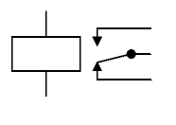

Black

L298 Out

Black

Steering Motor (C)

Black

Original Controller Connector (C)



Red

L298 Out

Brown

Steering Motor (C)

Red

Original Controller Connector (C)

Relay: IN2

Relay: IN1



Black

Pedal

Red

Pedal



F

White

Stick Forward

O

Red

Stick Neutral

B

Stick Back

Relay: IN4

Relay: IN3

Connector D (Original Controller)

|  |  |  |  |  |  |  |
| --- | --- | --- | --- | --- | --- | --- |
| Color | Yellow | Orange | Blue | Black | White | Red |
| Marking |  | Center | Back |  | Forward |  |

Second Hack (Shi En, Hannah) 9 Sep 16

Pin Connections

|  |  |  |  |
| --- | --- | --- | --- |
| Arduino | Relay | Buttons | Bluetooth |
| 2 | IN 1 |  |  |
| 3 | IN 2 |  |  |
| 4 | IN 3 |  |  |
| 5 | IN 4 |  |  |
| 6 |  | Forward |  |
| 7 |  | Backward |  |
| 8 |  | Left |  |
| 9 |  | Right |  |
| 10 |  |  | TX pin |
| 5v | 5v | 5v (Red) | 5v in (regulator) |
| Gnd | Gnd | Gnd (black) | Gnd |

Relay Connections



12V

Red

Steer Motor (C)

Gnd

Relay: IN2



12V

Red

Steer Motor (C)

Gnd

Relay: IN1



12V

Black

Rear Motor (B)

Gnd

Relay: IN4



12V

Red

Rear Motor (B)

Gnd

Relay: IN3

Button Wires

Holes drilled to route wire from undercarriage to hole at steering wheel.

Batteries

2x 7.4 Lead Acid batteries were damaged from undercharging, and was replaced with a 12v Lead Acid battery.

Further work

* Add Speed control from Batteries to motors, jeep drives too fast. Possible solutions to slow it down:
  + Knob PWM Spindle controller
  + L298 and PWM from Arduino
  + 150w Buck converter, reduce voltage from batt to relays
* Complete installation of:
* Power ON/OFF switch
  + Do test of max power for
* Button/Button+BLE Control mode switches
  + Mode 1: Buttons only
  + Mode 2: Buttons and BLE override
  + Mode 3: Stick and Pedal only
* Implement Timers to smoothen BLE Code

13 Sep 16

Connection Diagram

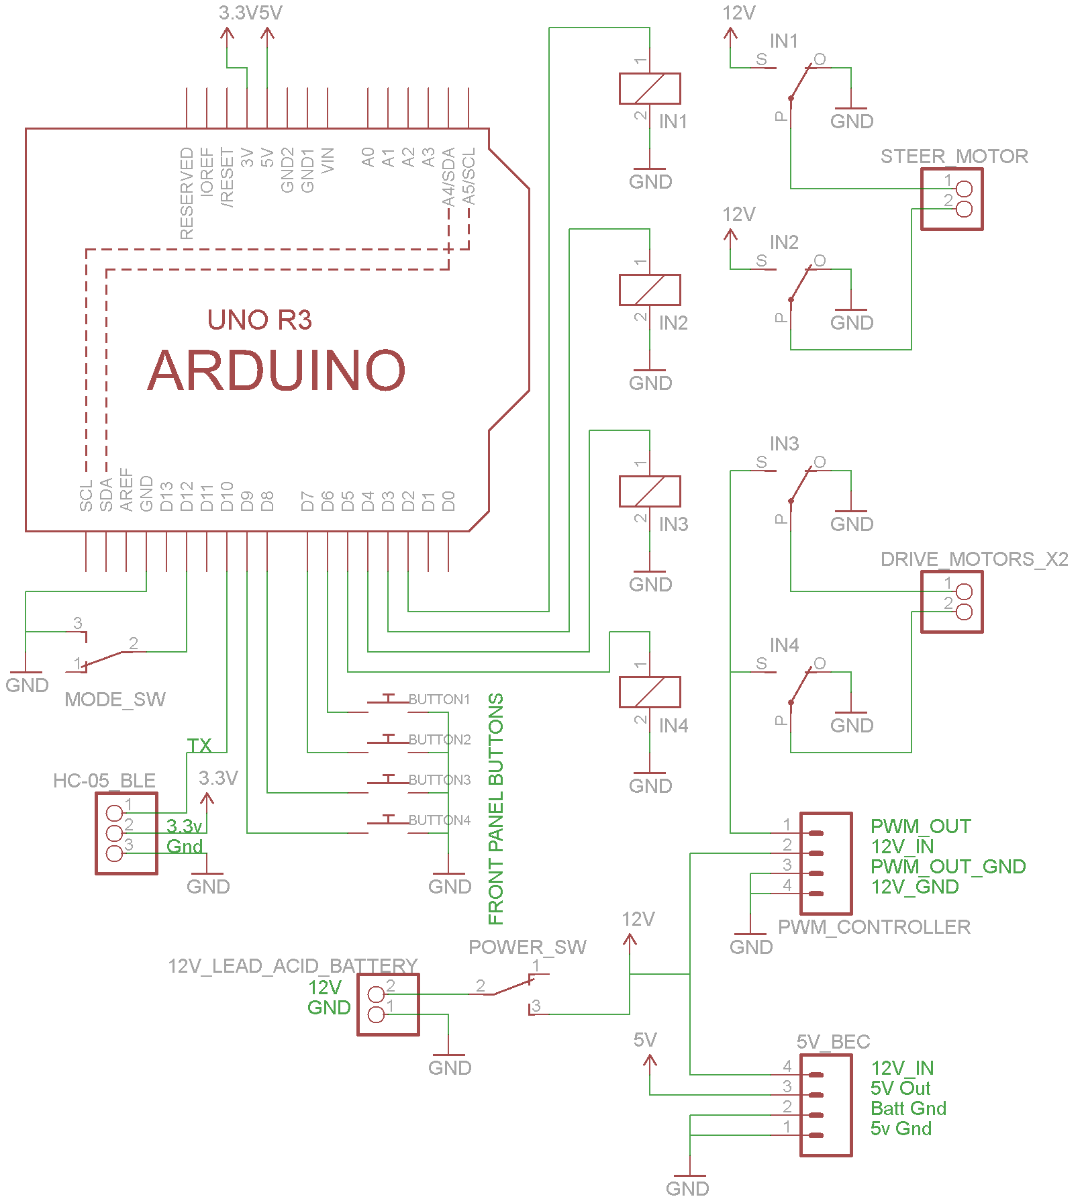

Components used

|  |  |  |
| --- | --- | --- |
| C:\Users\SE\Desktop\freaduino.PNG | Freaduino | <https://www.aliexpress.com/item/UNO-R3-compatible-improved-version-Freaduino-UNO-free-for-data-line/32293649198.html> |
| C:\Users\SE\Desktop\4Relay.PNG | 4 Relay Module | <https://www.aliexpress.com/item/4-channel-relay-module-4-channel-relay-control-board-with-optocoupler-Relay-Output-4-way-relay/32273435749.html> |
| C:\Users\SE\Desktop\SPindleController.PNG | PWM Spindle Controller | <https://www.aliexpress.com/item/12V-60V-10A-PWM-DC-brush-Motor-Speed-MACH3-spindle-Controller-12V-24V-48V/32494809920.html> |
| C:\Users\SE\Desktop\HC05.PNG | HC05 BLE | <https://www.aliexpress.com/item/2pcs-lot-Wireless-Master-Slave-Bluetooth-UART-Serial-Module-HC-05-HC-05-RF-Transceiver-Module/32723037992.html> |
| C:\Users\SE\Desktop\RockerSwitch.PNG | Rocker Switch x2 | <https://www.aliexpress.com/item/Promotion-10pcs-Red-Light-ON-OFF-SPST-Round-Rocker-Switch-6A-250V-10A-125V-AC/32564582334.html> |
| C:\Users\SE\Desktop\UBEC 5V.PNG | 5v UBEC | <https://www.aliexpress.com/item/General-RC-Part-Hobbywing-3A-Switch-Mode-UBEC-5V-6V-max-5A-Lowest-RF-Noise/32363675945.html> |
| C:\Users\SE\Desktop\Jumper.PNG | F-F Jumper wire | <https://www.aliexpress.com/item/Free-Shipping-400pcs-dupont-cable-jumper-wire-dupont-line-female-to-female-dupont-line-20cm-1P/1701745819.html> |

Controller by phone app

App: Joy BT Commander (From Google Play Store, Android devices only)

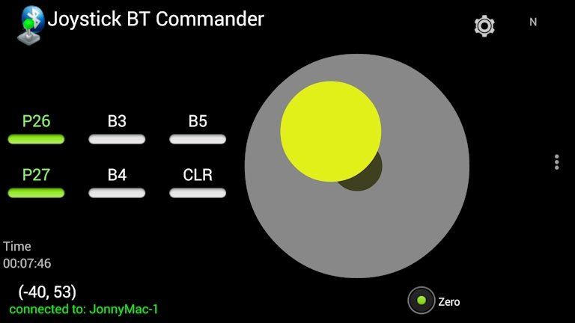

Select

1. Factory settings: Settings – reset Opt.
2. Connect Bluetooth: Connect – Select HC-05
   1. (if not found, go to Bluetooth settings, forget existing bindings)

Code:

<https://github.com/Shine16/HackAJeep>

Timer integrated for jeep to disable if BLE signal is cut.

Use of Timer in Arduino: When receiving a BLE signal every 50ms, variable receivedflag is set 1. Variable receivedflag is reset to 0 by the timer service routine every 300ms. If receivedflag is still read as 0 at the start of each 300ms interval, it means that BLE signal has cut off and mode is set to 2, to disable jeep.

Bluetooth app was chosen as it continuously sends data every 50ms by default even without button presses.

Current configuration

* Switch at rear left top of jeep: Power ON/OFF
* Switch at rear left side of Jeep: 2 modes: Button control, Button and BLE override
  + In Button control mode, control with buttons/joystick only
  + In Button and BLE override, control with buttons/joystick. BLE control will override button/joystick control. If BLE signal disconnects, jeep will be disabled.
* Knob at rear left behind of jeep under light: PWM spindle control, controls forward driving speed.

Further work

* External Leads by screws for connecting 12v lead acid charger to battery for easier charging.
* New front panel Button mounting, possibly 3d print and fit to squarish protrusion at the front panel of car.
* Secure jumper wire connections with hotglue/epoxy.